Version 1.0

Revision History

|  |  |  |  |
| --- | --- | --- | --- |
| **Date** | **Version** | **Description** | **Author** |
| 15/12/2019 | 1.0 | Final | Quản Trọng Tú |
|  |  |  |  |
|  |  |  |  |
|  |  |  |  |

Table of Contents

1. Use-Case Name 4

1.1 Brief Description 4

1.2 Actor 4

2. Flow of Events 4

2.1 Basic Flow 4

3. Special Requirements 5

4. Preconditions 5

5. Postconditions 5

6. Extension Points 5

# Use-Case Name

## Brief Description

Company users have the right to apply for leave and be handled by the administrator, the admin will choose the leave to update the status and the processing date.

## Actor

Administrator

# Flow of Events

## Basic Flow

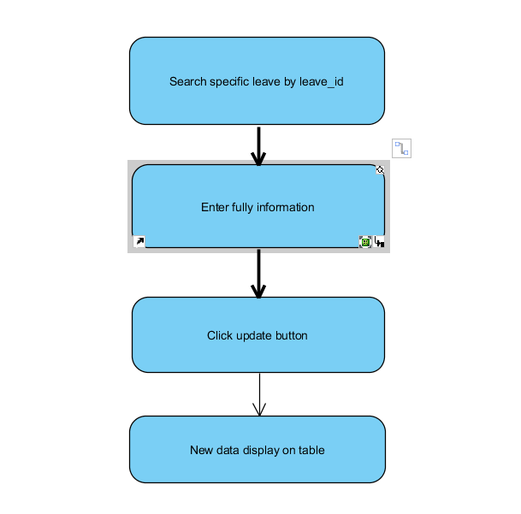

# Special Requirements

* Administrator need to input correctly constraint in search Field.

# Preconditions

Administrator have to login into this application and access Approve/Reject Leave view.

# Postconditions

Show Message if its fail or failure. If it is successful, all information will display.

# Extension Points

No extension points.